**Assign-04** : The “*Can We Talk*” System **[TESTS]**

# Who Is Doing the Testing?

|  |  |
| --- | --- |
| ***User-1*** Name and Linux VM IP Address | Name: __user1____DeyiZou_____________  IP Address: ____127.0.0.1___________________ |
| ***User-2*** Name and Linux VM IP Address | Name: ___user2_____Zhizheng Dong__________  IP Address: ____ 172.19.208.1__________ |

# Functional Tests

|  |  |
| --- | --- |
| Test ID | FT-01 |
| Steps | 1. User-1 send a 57 character message as follows:  **The quick brown fox jumped over the crazy lazy orange cow**  2. Each user takes and records a screen capture of their client application after the message is sent and received |

User1:

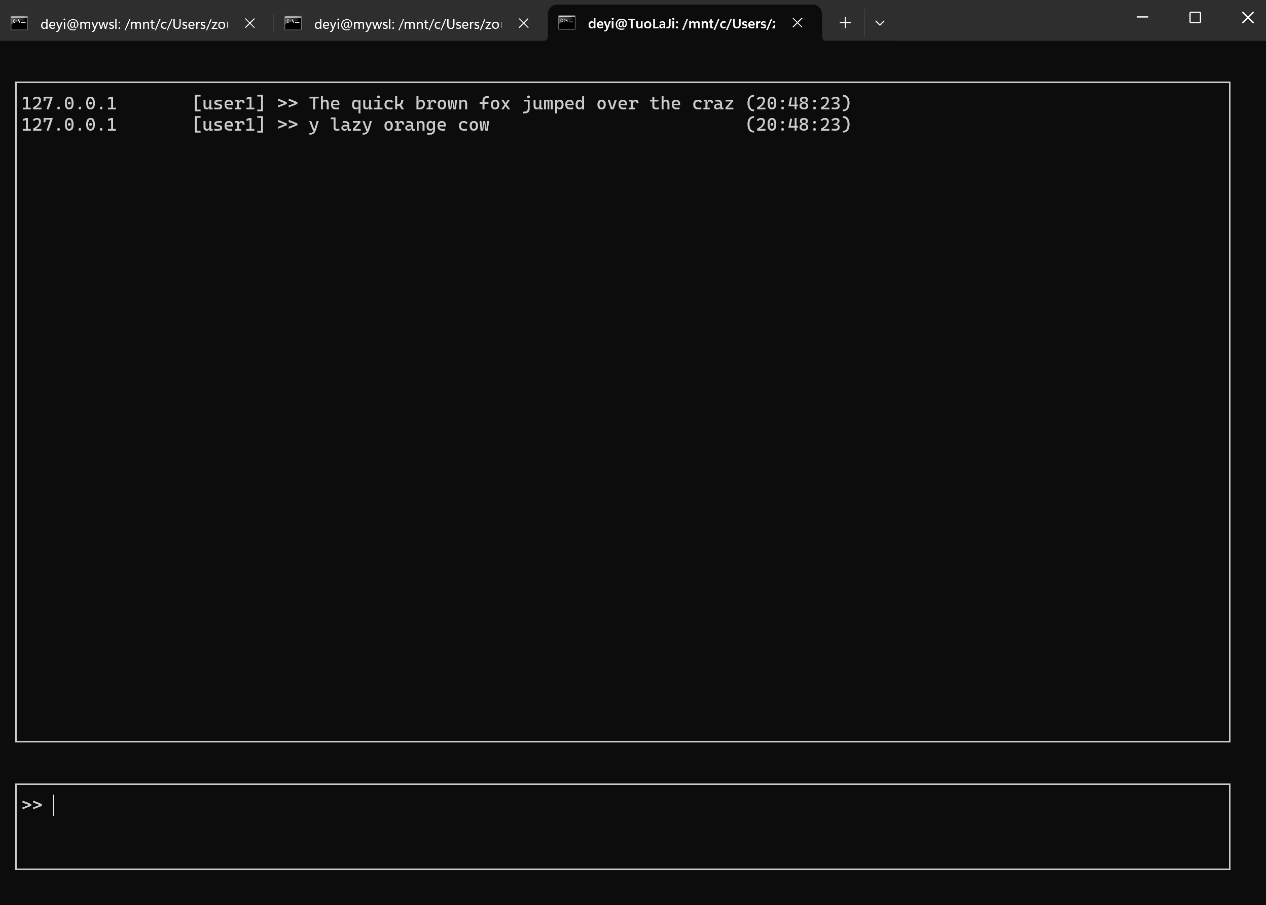

User2:

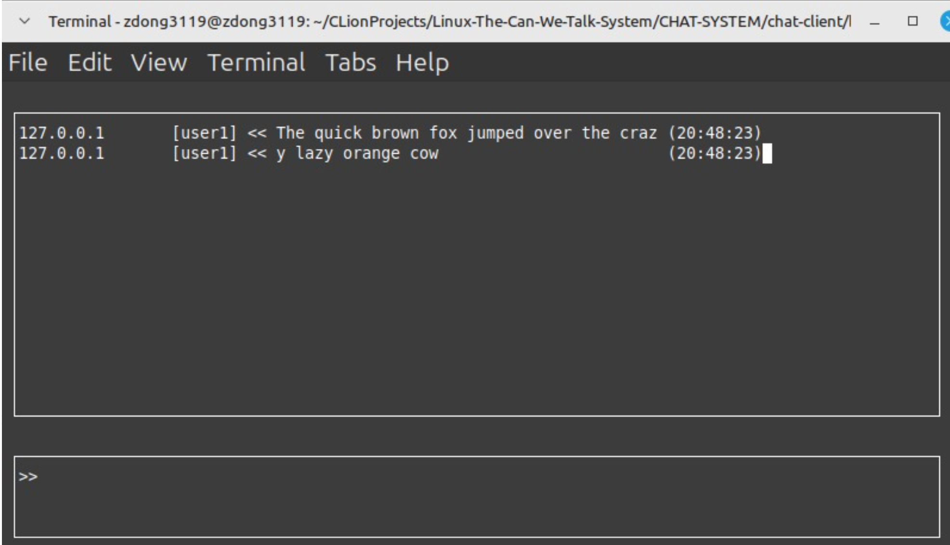

|  |  |
| --- | --- |
| Test ID | FT-02 |
| Steps | 1. This test can be completed immediately following FT-01  2. User-1 begins to enter a 57 character message as follows:  The quick brown fox jumped over the crazy lazy orange cow  3. While User-1 is entering the message (and before pressing send on the message), User-2  enters the message Hello and presses send.  4. User-1 takes and records a screen capture as soon as the Hello message arrives from User-2  5. Each user exits the client application and the chat-server application is to be terminated |

User1:

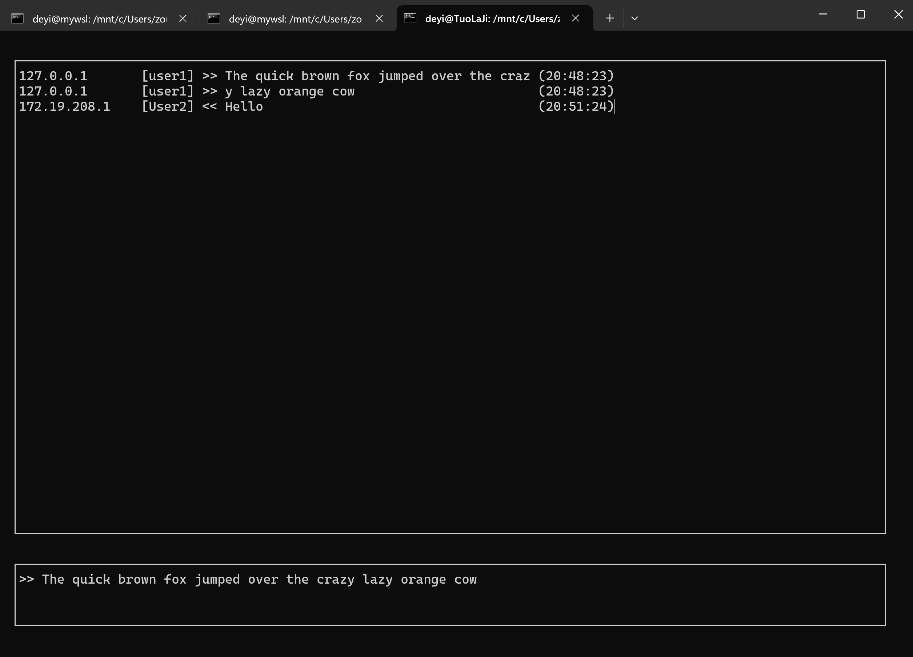

User2:

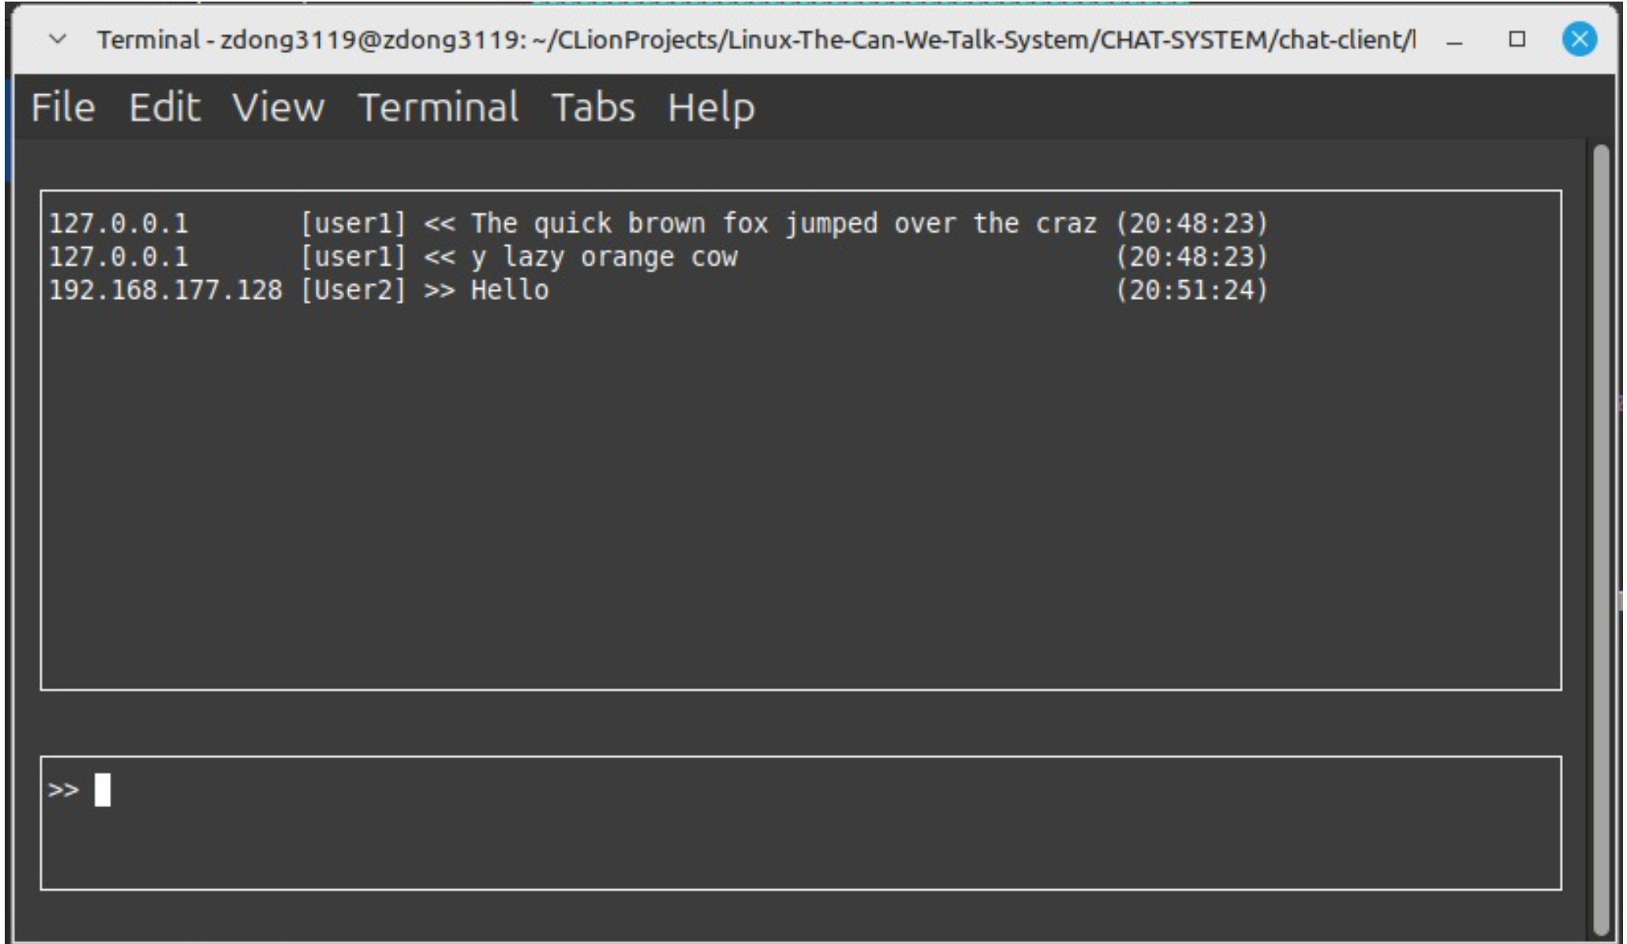

Server:

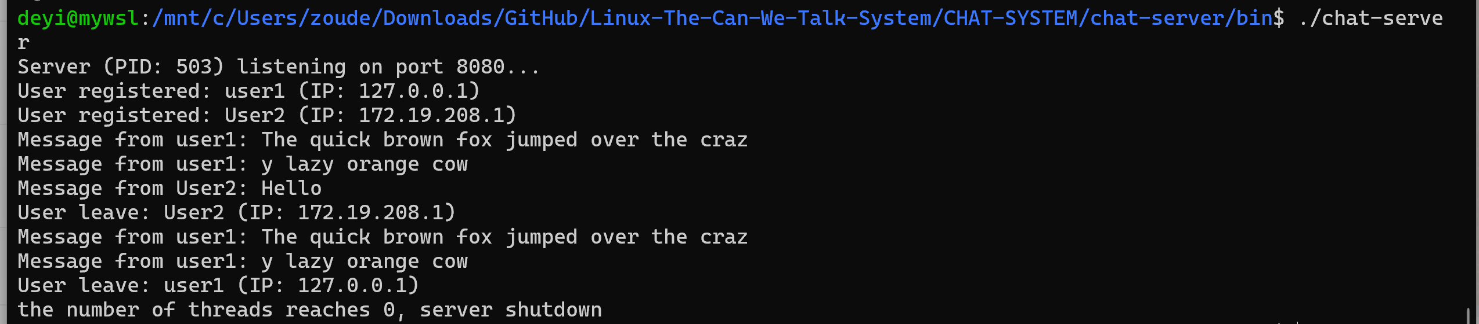

|  |  |
| --- | --- |
| Test ID | FT-03 |
| Steps | 1. The chat-server application and both chat-client applications need to be restarted  2. User-1 and User-2 will take turns entering and sending messages (back and forth). The  message contents will simply be in the format **message-##** where **##** starts at **01** for each  user and ends at **05**.  3. After each user has entered their next message – each user takes and records a screen  capture of their client application |

User1:

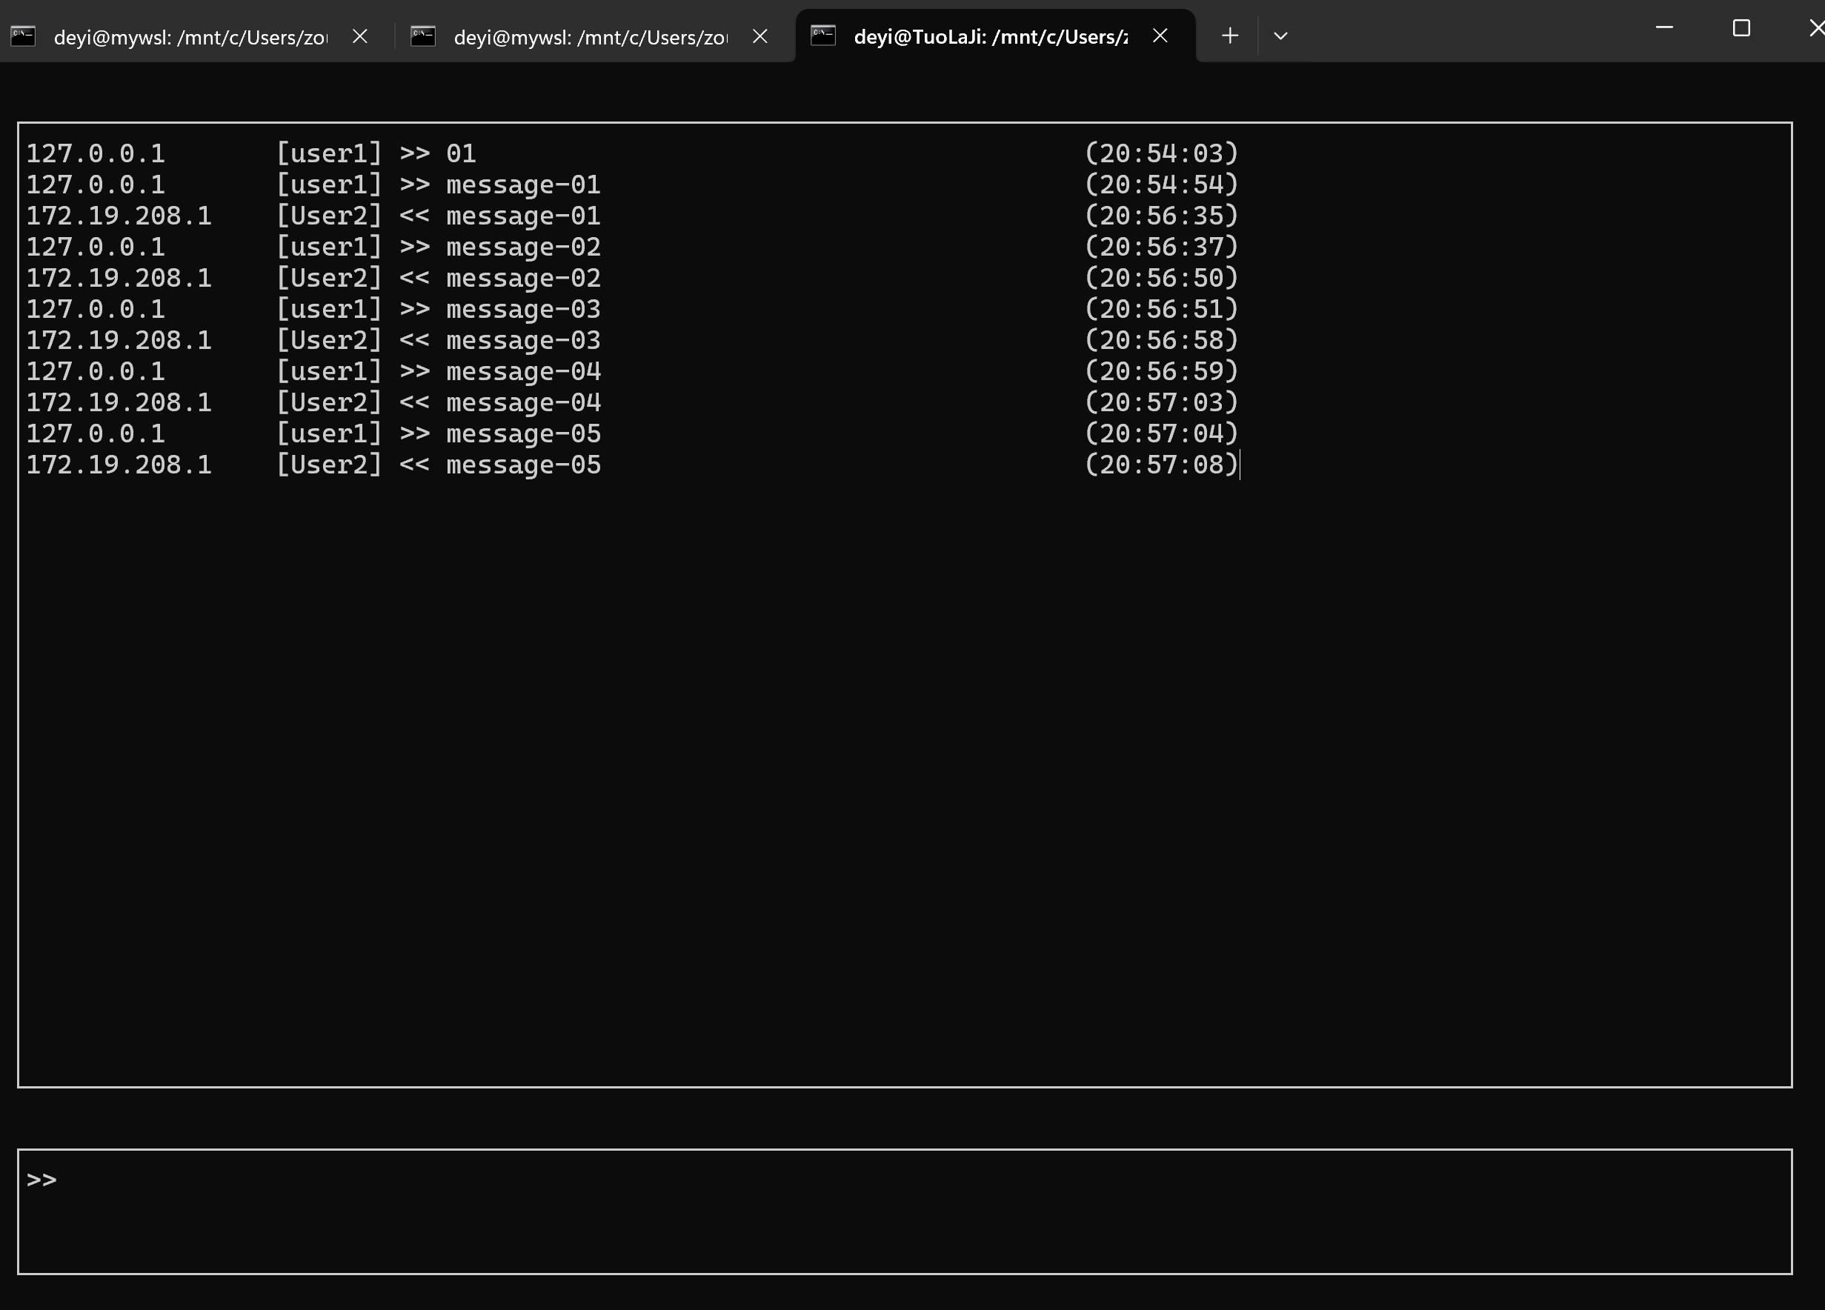

User02:

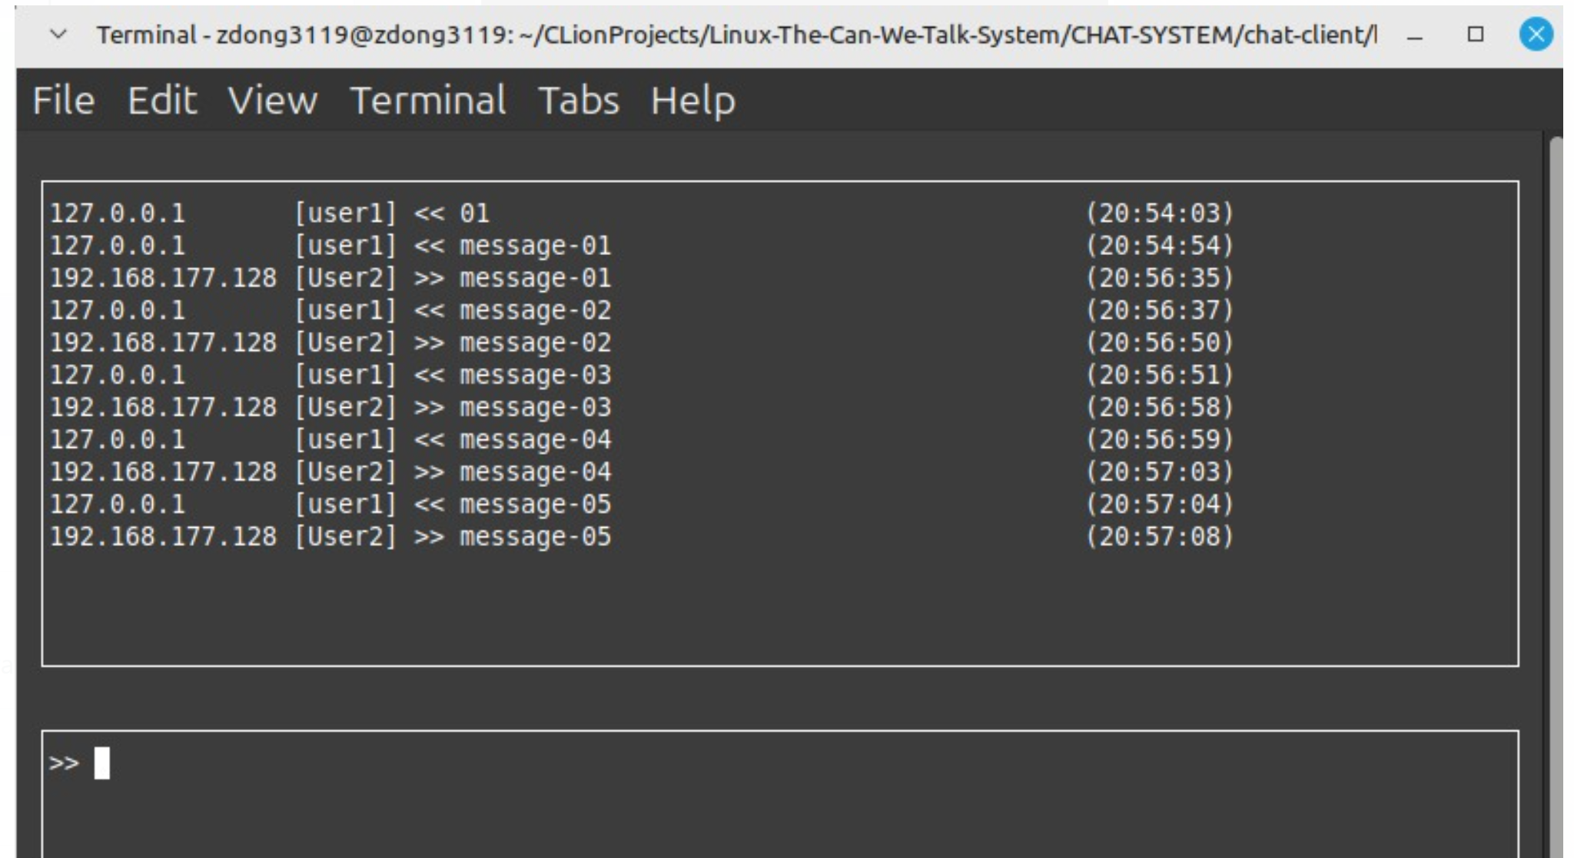

|  |  |
| --- | --- |
| Test ID | FT-04 |
| Steps | 1. This test is to be completed after FT-03 without restarting any application  2. User-1 enters the message **message-06** and presses send  3. Each user takes and records a screen capture of their client application |

User1:

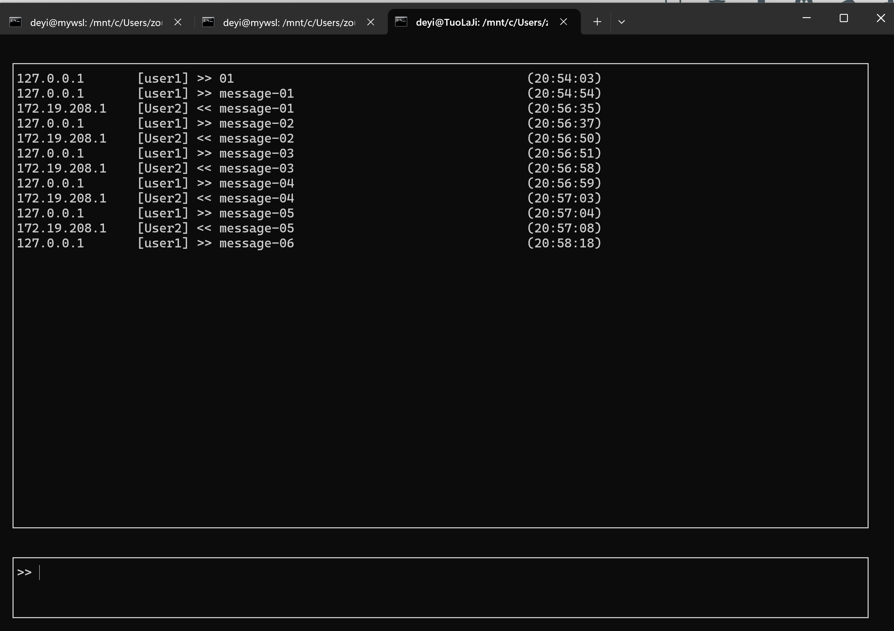

User2:

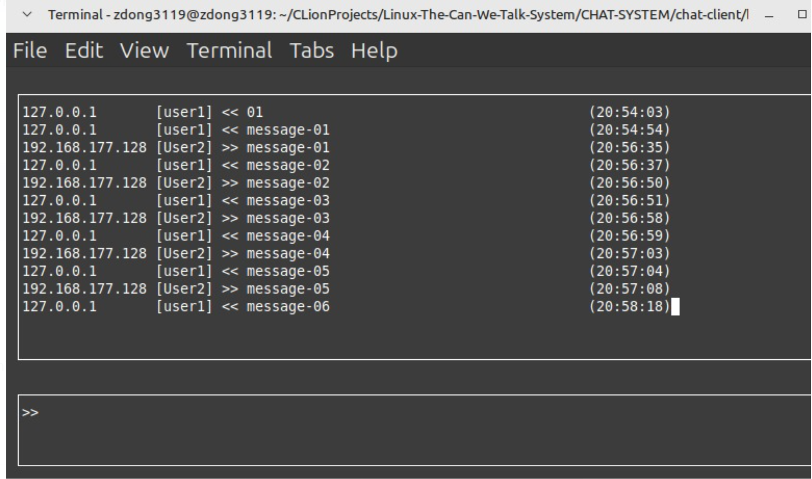

# Boundary Tests

|  |  |
| --- | --- |
| Test ID | BT-01 |
| Steps | 1. This test is to be completed after FT-04 without restarting any application  2. **Synchronizing the sending of the message in this test is critical!** So please ensure that  both users press send at the same time on their keyboards  3. Each user enters the message **Let’s see if this works** and waits to press enter to send …  • Since you are potentially testing on one VM – then ensure that you have entered the text (without pressing send) in your two *client* windows  • Prepare your two client windows so that you can switch between them and press enter as quickly as possible … clearly you will not be able to press enter at the same time in both windows – but press enter (in the following step) as quickly as you can in both client windows  4. Each user presses enter (in order to send the message) **at approximately the same time**  5. After receiving the messages, each user takes and records a screen capture of their  client application |

User1:

# **文本 AI 生成的内容可能不正确。**

# **User2:**

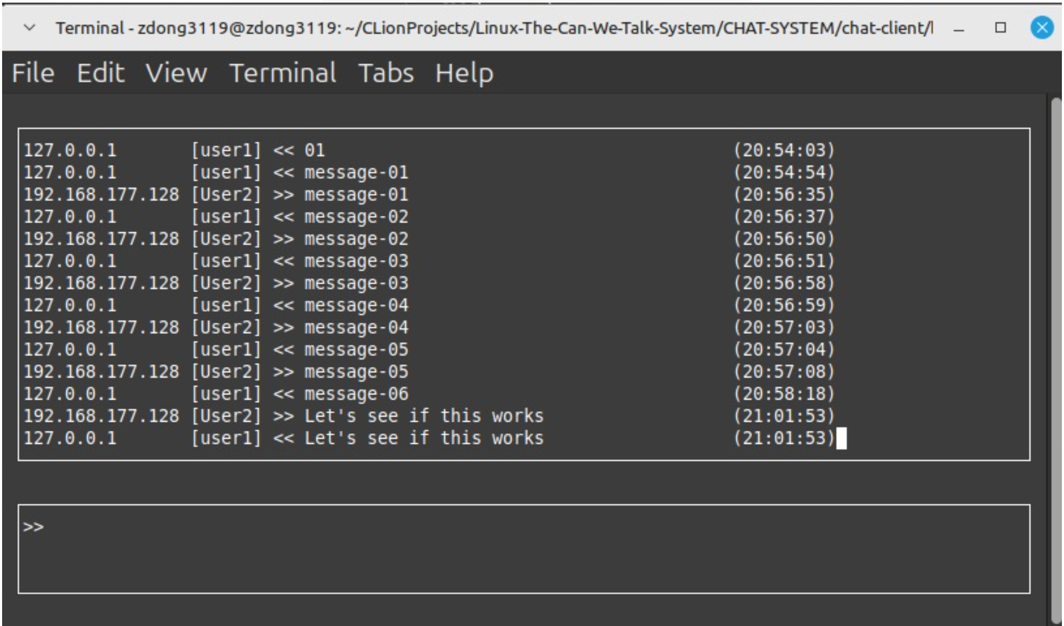

# Exception Tests

|  |  |
| --- | --- |
| Test ID | ET-01 |
| Steps | 1. This test is to be completed after BT-01 without restarting any application  2. User-1 needs to determine the PID of the chat-server process  3. **Synchronizing the sending of the message in this test is critical!** So please ensure that  both users press send at the same time on their keyboards  3. Each user enters the message **Let’s see if this works** and waits to press enter to send …  • Since you are potentially testing on one VM – then ensure that you have entered the text (without pressing send) in your two *client* windows  • As well in this test case, you need a third window (perhaps the window that the server is running in) – enter the **kill** command in the following step into this window and do not press enter  • Prepare your two client windows as well as the third window (with the kill command) so that you can switch between them and press enter as quickly as possible … clearly you will not be able to press enter at the same time in both windows – but press enter (in the following step) as quickly as you can in both client windows  4. User-1 enters the command kill -9 <PID> (where PID was determined in step 2 above) in a terminal on their machine  • execute the kill command in the third window and then switch to the two client windows and (as quickly as possible) execute steps 5 below  5. Each user then presses enter (in order to send the message) **at approximately the same time**  6. Each user takes and records a screen capture of the terminal window where their client application was running after pressing send  - ensure that each client is closed |

User1:

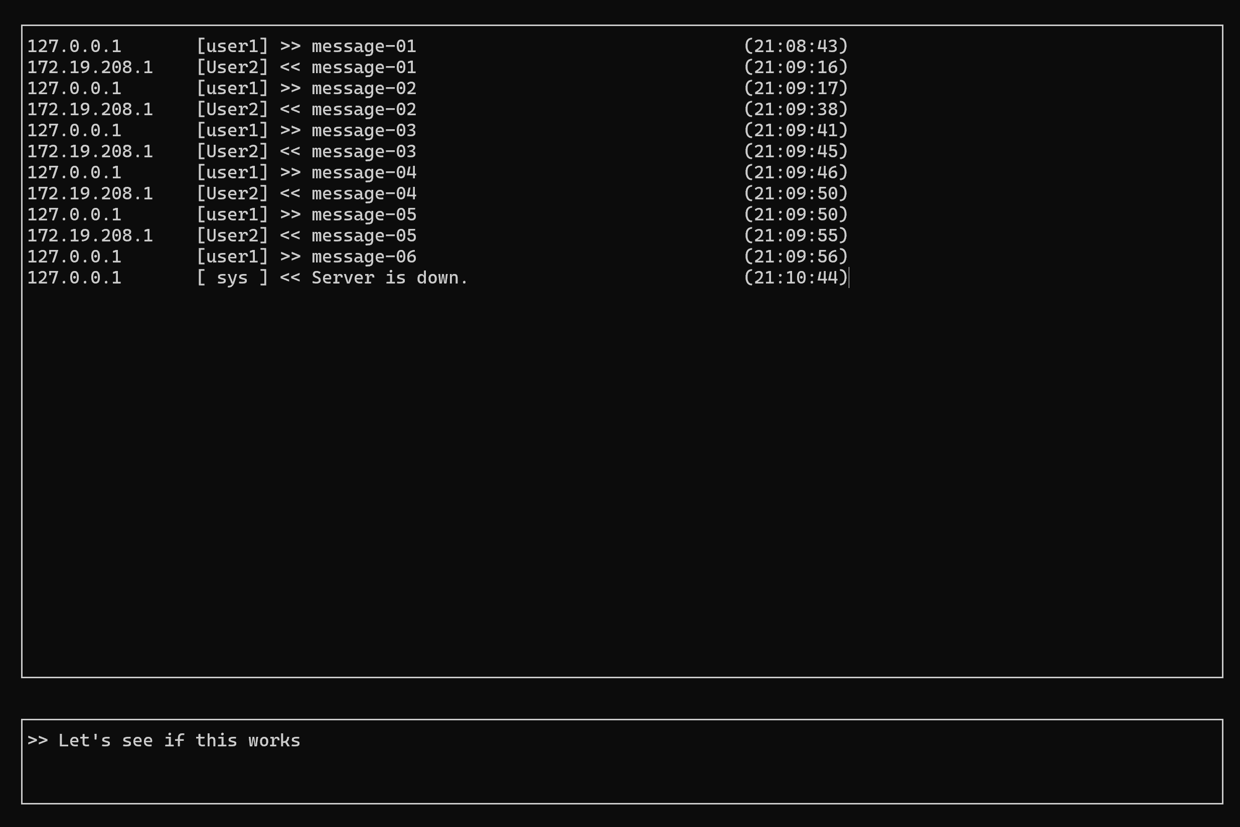

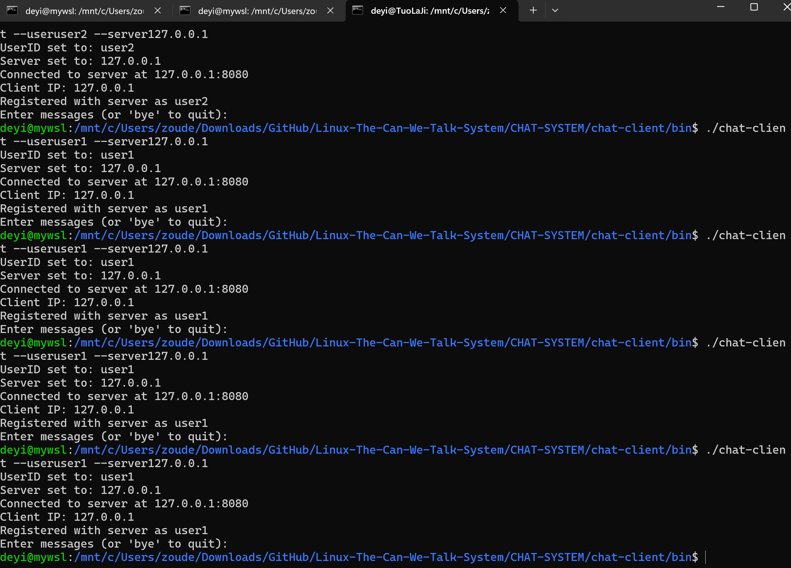

User2:

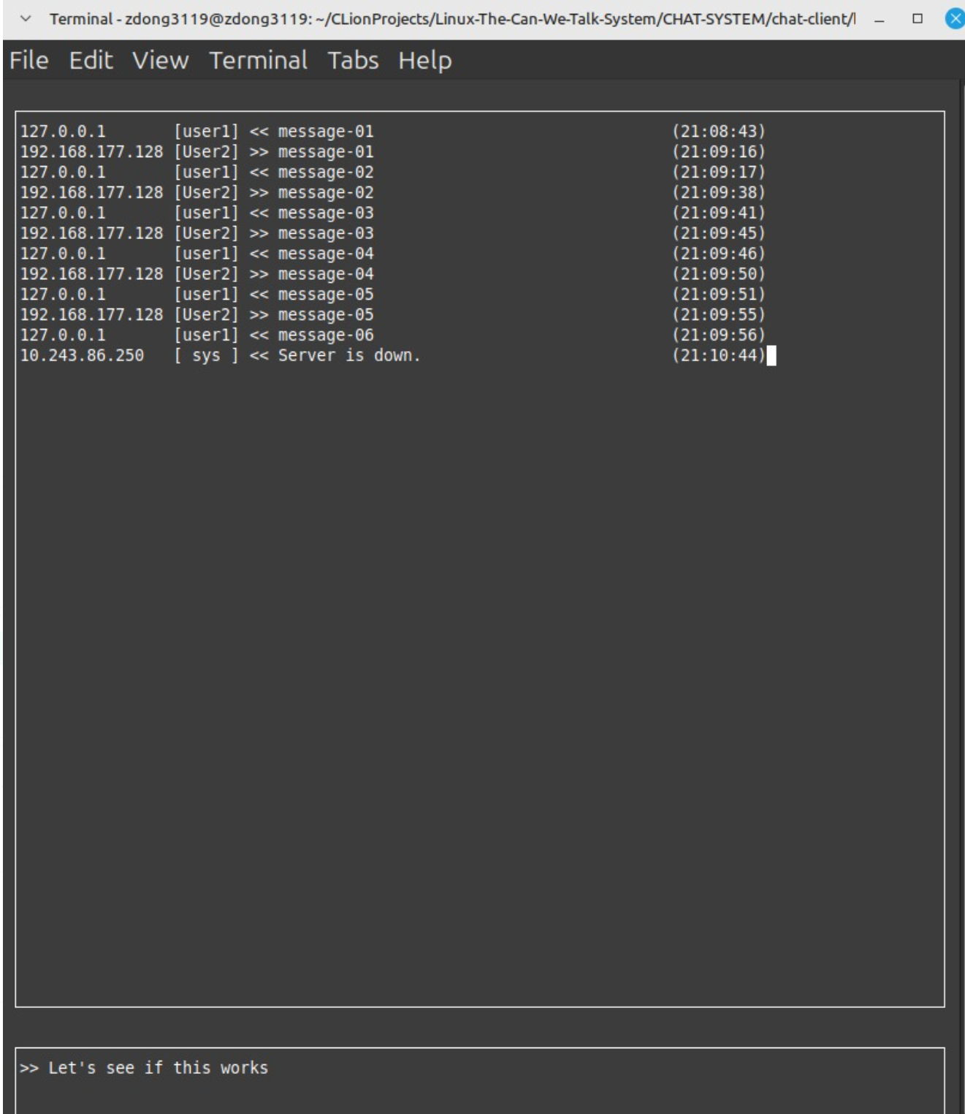

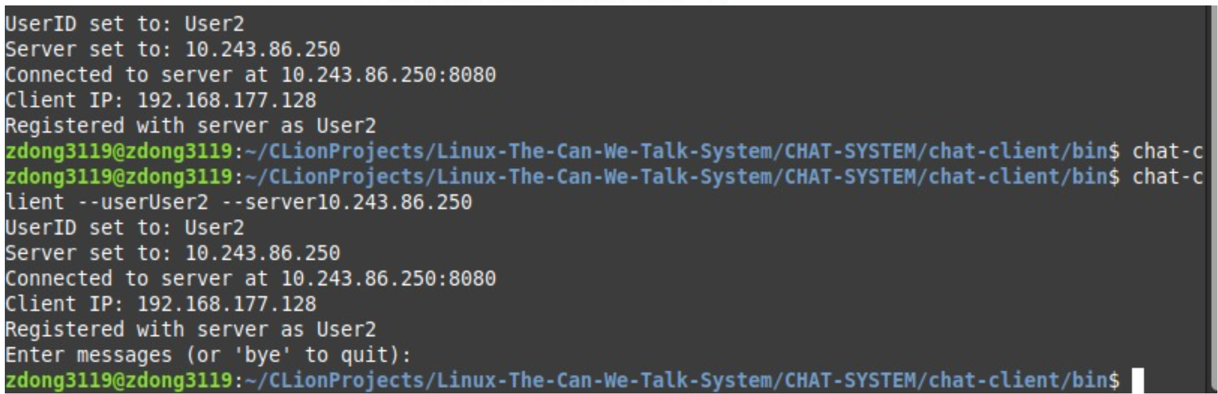

|  |  |
| --- | --- |
| Test ID | ET-02 |
| Steps | 1. The chat-server application and both chat-client applications need to be restarted  2. User-1 enters the message **>>bye<<** and sends it. After the message is sent, ensure that each user takes and records a screen capture of their client application  3. User-2 enters the message **>>bye<<** and sends it. After the message is sent, ensure that each user takes and records a screen capture of their client application  4. On the Linux VM where the chat-server application is running, launch a new terminal and enter the command: ps –eaf | grep chat Take and record a screen capture of the results. |

User1:

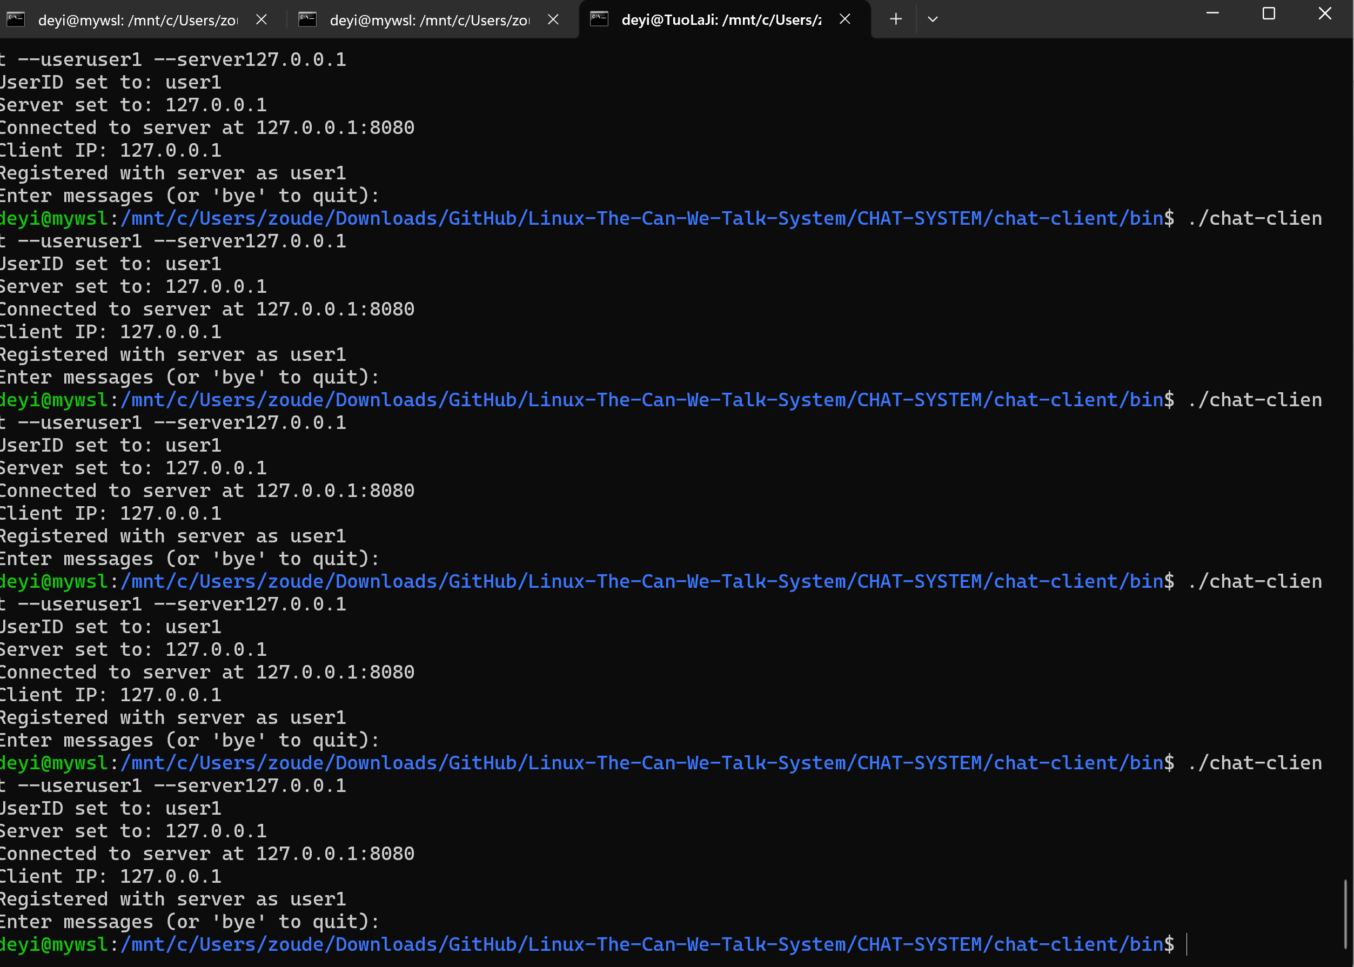

User2:

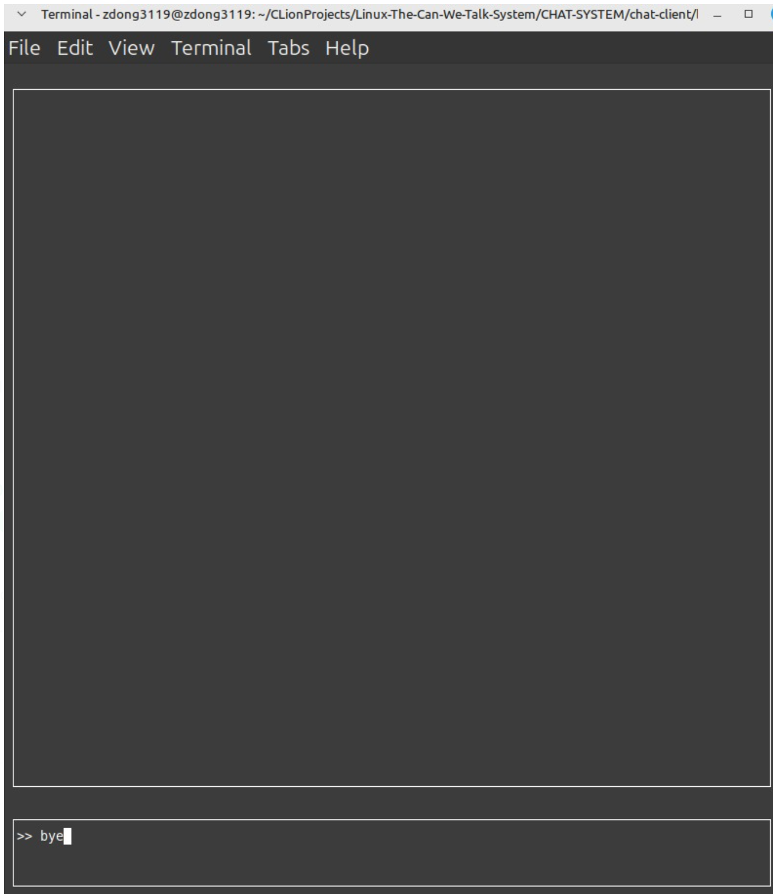

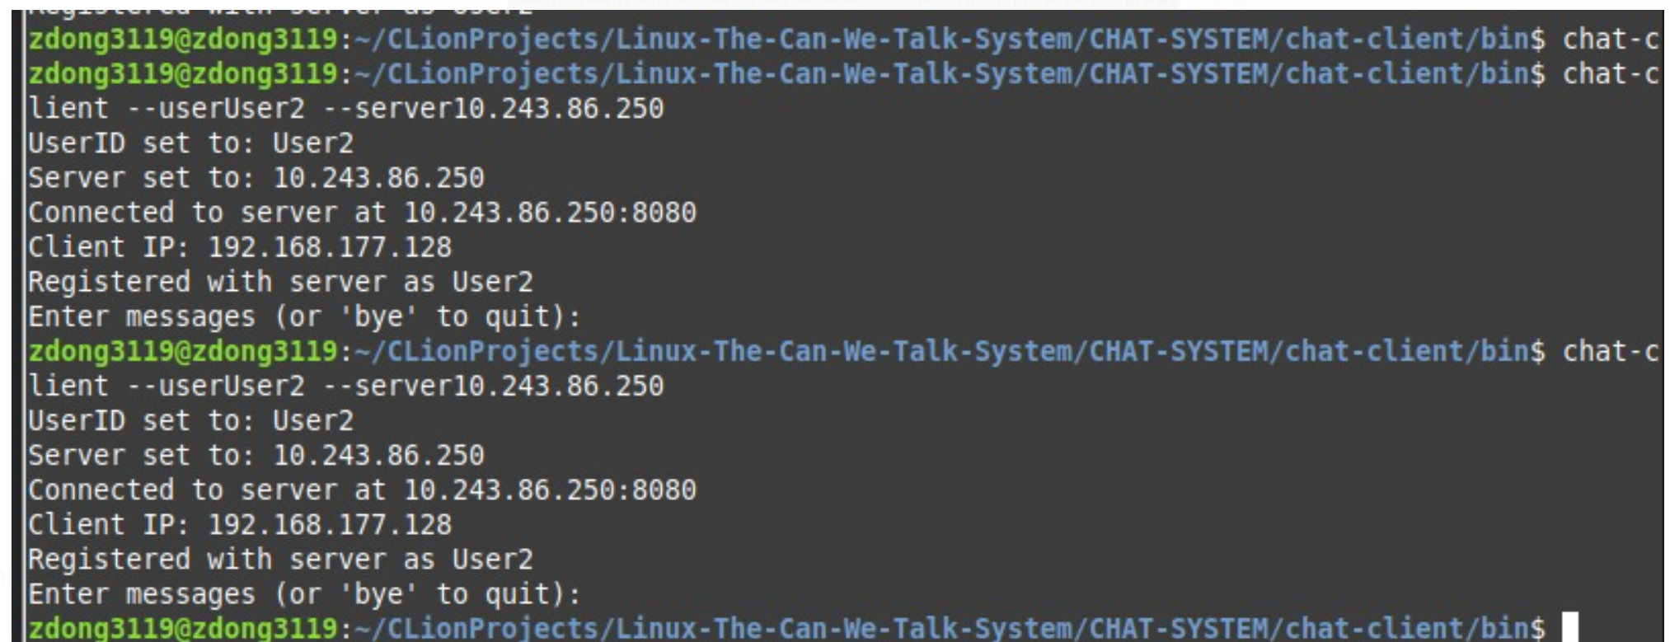

Server:

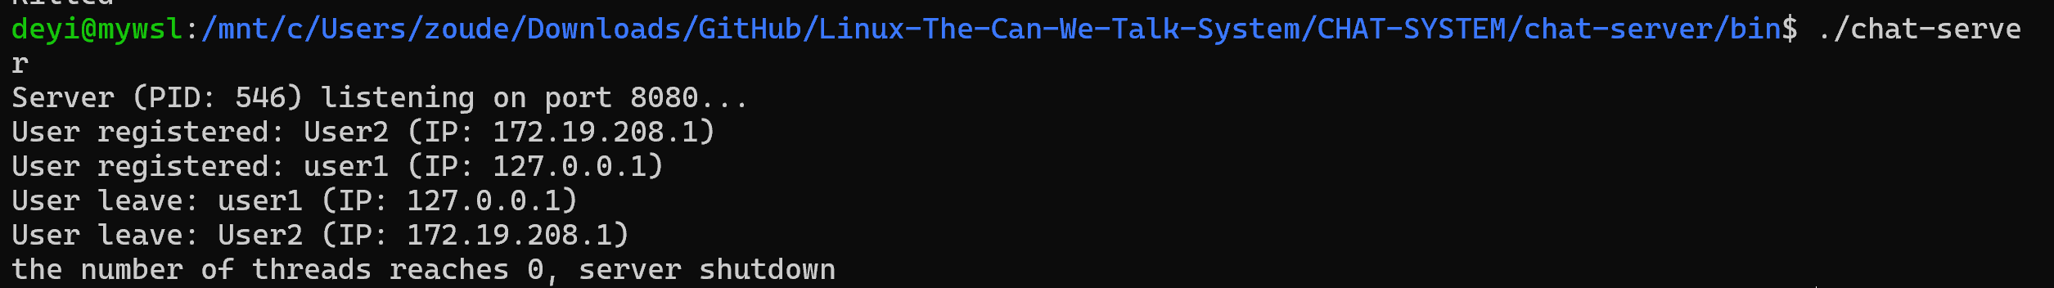

Final:

